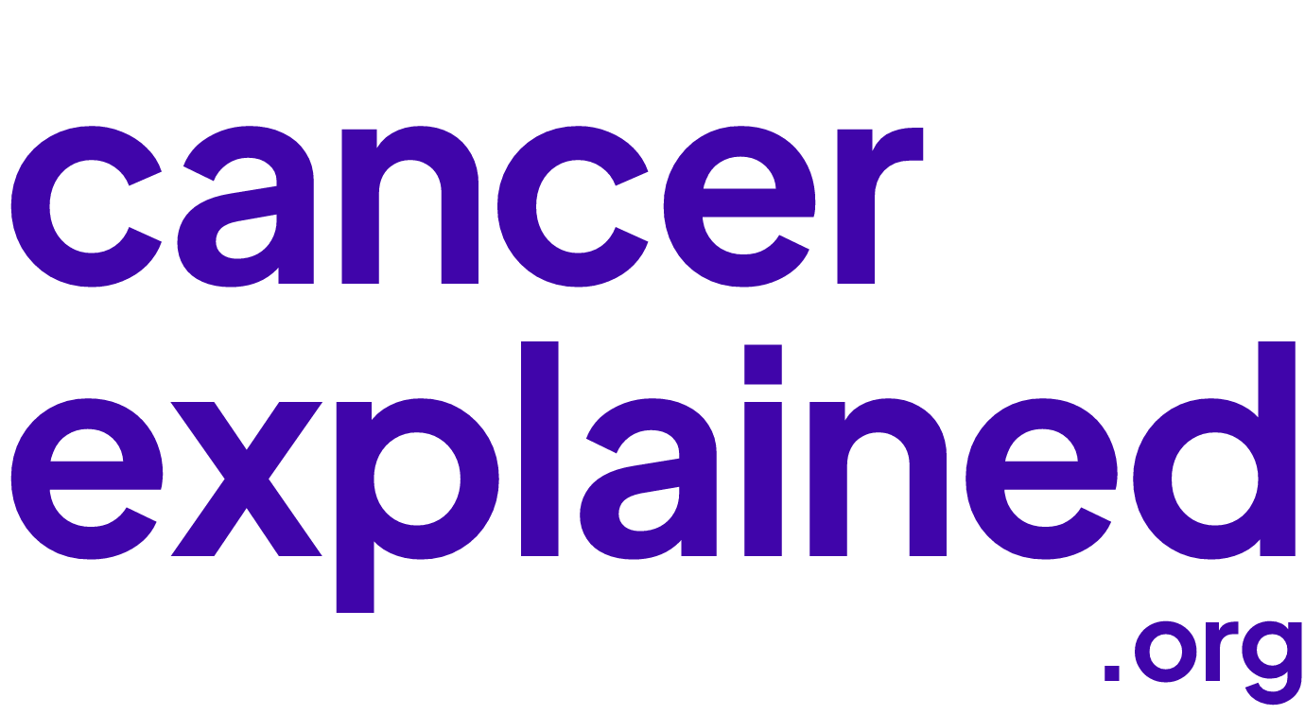

Cancer Explained media kit
For journalists and partners | Updated September 22, 2026
Cancer Explained makes cancer information easier to understand. This kit provides organization facts, reusable descriptions, editorial context, brand assets, and contacts for coverage and collaboration.

Organization at a glance
Public project | Cancer Explained
Operating organization | National Cancer Information Foundation
Mission | Free plain-language cancer education
Legal status | Wyoming public benefit nonprofit corporation; IRS-recognized 501(c)(3) public charity
Incorporated | July 6, 2026
IRS recognition | July 13, 2026; exemption effective July 7, 2026
EIN | 42-3639534
Website | cancerexplained.org

Media contact
For media enquiries, interview requests, and requests for comment, email press@cancerexplained.org. Please include your outlet, topic, deadline, time zone, and preferred interview format.
Organization facts: cancerexplained.org/about/ and cancerexplained.org/transparency/. Contact: cancerexplained.org/contact/.

Descriptions and story ideas
Use these descriptions when introducing Cancer Explained in an article, newsletter, event listing, or partner resource.

One sentence
Cancer Explained provides free, plain-language cancer education for patients, caregivers, families, and the public.

Short description
Cancer Explained is the public education project of National Cancer Information Foundation, a Wyoming nonprofit recognized by the IRS as a 501(c)(3) public charity. The website makes cancer information easier to understand through plain-language explanations, guided reading paths, and practical educational tools. It draws chiefly on National Cancer Institute resources and other published public health sources. Content is free to access, with no ads, paywall, or account required. Visit cancerexplained.org.

Extended description
Cancer Explained helps patients, caregivers, families, and the public understand cancer information and prepare for conversations with their care teams. Operated by National Cancer Information Foundation, a Wyoming nonprofit recognized by the IRS as a 501(c)(3) public charity, the website offers plain-language explanations, visual learning, guided reading paths, and educational tools. Its content draws chiefly on the National Cancer Institute and other published public health sources, with links to the underlying material. The site uses an AI-assisted editorial system and automated checks; pages are not routinely reviewed by a named clinician before publication. Cancer Explained provides education, not diagnosis, treatment recommendations, or individualized medical advice. Resources are free to access, with no ads, paywall, or account required. Learn more at cancerexplained.org.

Story ideas
Making cancer information understandable. How plain-language explanations and guided reading paths can help people navigate unfamiliar terms.
Questions beyond the diagnosis. The information needs of caregivers, families, and people who are worried about symptoms.
Transparency in AI-assisted education. How a nonprofit explains its sources, automated checks, corrections process, and limits on clinical review.
Story ideas describe potential coverage topics, not claims of measured outcomes or offers of clinical expertise.

Editorial approach and context
Cancer Explained links readers to its published sources and explains how its pages are created. The following context supports accurate coverage.

Who the site serves
The site serves patients, caregivers, families, and anyone seeking to understand cancer. Readers can explore topics, follow guided reading paths, find educational tools, or use Ask Cancer Explained to ask questions in their own words. English and Spanish resources are available.

How the content is produced
An AI-assisted editorial system works from published public health sources, chiefly the National Cancer Institute, alongside other sources such as MedlinePlus, the American Cancer Society, the FDA, and the CDC. The site publishes its editorial rules, applies automated checks, and provides a route for reporting corrections.

What clinical review means
Pages are not routinely reviewed by a named clinician before publication. A page should only be described as medically reviewed when it identifies a named, credentialed reviewer and a review date. Automated checks and source citations do not by themselves constitute clinical review.

The relationship to the National Cancer Institute
Cancer Explained is operated by National Cancer Information Foundation. It is not the National Cancer Institute. The National Cancer Institute and other cited organizations do not endorse the site.

Education and medical care
Cancer Explained provides general educational information. It does not diagnose, recommend treatment, or provide individualized medical advice, and it does not replace a qualified healthcare professional.

Public information and interview requests
The organization does not publish personal details of its directors, officers, staff, or volunteers. Route interview requests through press@cancerexplained.org. Requests for governing documents, filings, or officer and director information can be sent in writing to legal@cancerexplained.org.
Read more: cancerexplained.org/ai-use/ • cancerexplained.org/editorial-process/ • cancerexplained.org/medical-review-policy/ • cancerexplained.org/transparency/

Brand assets and contacts
Use the supplied assets to identify Cancer Explained clearly and consistently. The wordmark and ce short logo reproduce the artwork used on the current website.


Names and visual identity
Write Cancer Explained in prose and cancerexplained.org for the web address. Use National Cancer Information Foundation when naming the operating organization. The primary logo is the lowercase two-line wordmark; ce is the short version for avatars and compact placements.
Use violet or ink artwork on light surfaces and white or lavender artwork on dark surfaces. Preserve the proportions, spacing, and letterforms. Keep a clear margin around each logo and avoid filters, shadows, stretching, or combining ce with the wordmark as a new logo.

Included assets
The assets/logos folder includes SVG masters and PNG exports of the stacked and horizontal wordmarks and ce avatars. Plus Jakarta Sans font files and their license are included in assets/fonts. Brand colors are deep violet #4005AA, ink #181A2C, paper #FBF8FF, lavender #CDBDFF, and mist #E8DEFF.

Images and attribution
Identify the organization as Cancer Explained and link to cancerexplained.org when practical. The separate social library includes AI-generated illustrative photography; these scenes must not be described as actual patients, staff, testimonials, or documentary evidence. Contact the press inbox for additional imagery, captions, or reuse questions.
Press and interviews | press@cancerexplained.org
Partnerships | partnerships@cancerexplained.org
General enquiries | info@cancerexplained.org
Corrections | corrections@cancerexplained.org
Governance and legal | legal@cancerexplained.org

Official information: cancerexplained.org/about/ • cancerexplained.org/contact/ • cancerexplained.org/transparency/

